
Role Play

The Job Negotiation:
Role of the Candidate
06/2024-6920
This role play was written by Martin Schweinsberg, Associate Professor of Organisational Behaviour at ESMT Berlin, Horacio Falcão, Professor of Management Practice of Decision Sciences at INSEAD, Warren Tierney, Postdoctoral Research Associate at INSEAD, and Eric Uhlmann, Professor of Organisational Behaviour at INSEAD. It is intended to be used as a basis for class discussion rather than to illustrate either effective or ineffective handling of an administrative situation.
The authors gratefully acknowledge funding from the Hoffmann Institute.
To access INSEAD teaching materials, go to https://publishing.insead.edu/.
Copyright © 2024 INSEAD
Copies may not be made without permission. No part of this publication may be copied, stored, transmitted, translated, reproduced or distributed in any form or medium whatsoever without the permission of the copyright owner.

You are M. Duarte, an aspiring professional in the tech industry. You recently interviewed for a position in the marketing department at the Abere company, one of the more well-known Europe-based companies in your country. After a few rounds of intense interviews the Abere company recruiter contacted you a few days ago and said you had been selected among many candidates and that they would like to make you an offer. You were excited and agreed to the offer in principle. You are now about to discuss the details of the offer in your upcoming conversation with the Abere recruiter.
You are really excited about working in this industry because you can clearly see how it fits well with your interests and potentially with your skills. In addition, this particular role would allow you to work creatively within a team well-known for their greatly supportive culture, something you’re really excited about. Given the current economic climate, the Abere offer is clearly the best offer you will be able to get at the moment.
As you think more carefully about this upcoming conversation with the Abere recruiter, you realize that all of the following issues are important to you:
- base pay and bonus
- holidays
- office location
- health insurance coverage
- team size
- start date
- subsidy for MBA / training
- flex time
However, not all of these are equally important to you. Apart from an attractive salary (base pay and bonus) and holidays you also care about a few other issues. You are also looking for extensive leadership experience in this job so the opportunity to manage a sizeable team of other employees is important to you.
You are the eldest in a family of five where all are currently uncovered health-wise, so it's important that your health insurance plan also covers additional family members. Staying close to your family also means that you want to work in the new city (rather than the historic older part of the city) since this would cut your total commute from 4 hours down to 2.
In addition, you care a lot about your further education and so you would like to receive a subsidy for further training and education. It would also be convenient to have some flexibility at work for courses that conflict with the normal job hours. Thus, one day a week means that for one day, you do not need to be there from 9 am until 5pm, but rather could take off to take care of other commitments and then compensate the hours from home later in the day or even during the weekend.
You are currently finishing your education and wish to avoid interrupting it because of this job. That is why starting the job later would actually be better than earlier, even though you could do with the money now. Moreover, as you start work, you already have a plan to do an MBA or a relevant specialized master’s later on, preferably an international one. You know that they have a program that can credit 1%-5% of one’s compensation towards future education. If you could ensure Abere will consider subsidizing your future education in three to four years down the road at the highest possible rate, this would also be a great success.
The table below shows you how important each of these issues is to you. Different levels of agreement are worth different number of points to you. For example, your best possible outcome on salary gives you 2250 points but your best possible outcome on team size only gives you 1650 points.
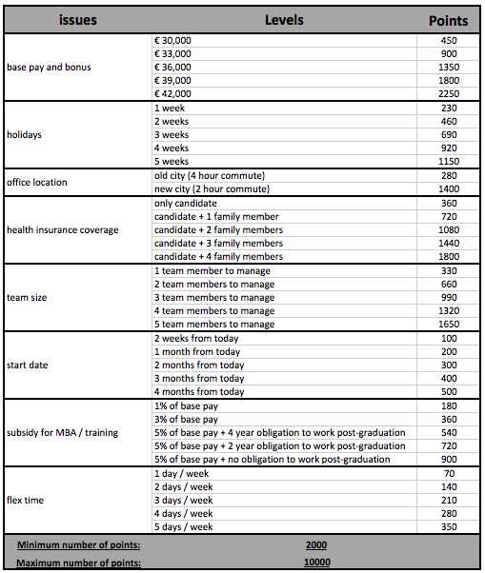
Thus, the maximum number of points you get from this negotiation is 10,000 pts and the minimum is 2,000 pts. If you do not reach an agreement with the recruiter you receive 0 pts.
Please prepare for your conversation with S. Alvarez from Abere Company now. Your goal in this negotiation is to achieve as many points for yourself as possible from all 8 issues. Note that you can only sign the contract if you and S. Alvarez agree on all 8 issues. Also note that it’s important to keep a good relationship with S. Alvarez as you negotiate this contract. S. Alvarez could potentially be important for your future career at Abere Company so make sure you get a good deal for yourself while also building a good relationship with S. Alvarez.

