
Role Play

The Job Negotiation:
Role of the Recruiter
06/2024-6920
This role play was written by Martin Schweinsberg, Associate Professor of Organisational Behaviour at ESMT Berlin, Horacio Falcão, Professor of Management Practice of Decision Sciences at INSEAD, Warren Tierney, Postdoctoral Research Associate at INSEAD, and Eric Uhlmann, Professor of Organisational Behaviour at INSEAD. It is intended to be used as a basis for class discussion rather than to illustrate either effective or ineffective handling of an administrative situation.
The authors gratefully acknowledge funding from the Hoffmann Institute.
To access INSEAD teaching materials, go to https://publishing.insead.edu/.
Copyright © 2024 INSEAD
Copies may not be made without permission. No part of this publication may be copied, stored, transmitted, translated, reproduced or distributed in any form or medium whatsoever without the permission of the copyright owner.

You are S. Alvarez, a manager at the Abere Company, one of the leading Europe-based companies in the tech industry. The Abere Company is currently expanding their marketing department and after several rounds of interviews M. Duarte has emerged as the strongest candidate. One of your colleagues already offered M. Duarte the position and now it is up to you to negotiate the details of that offer with M. Duarte.
Abere Company is really excited about M. Duarte’s profile since there aren’t many qualified candidates on the market these days. The marketing department wasn’t impressed by any of the other candidates they interviewed and M. Duarte is therefore the best candidate Abere Company could get at the moment.
It’s important for you personally to sign M. Duarte: a number of candidates in other departments have recently declined their offers after your negotiations with them and so you’re keen to close a deal in your upcoming conversation with M. Duarte. However, you also have to budget constraints and you have to ensure that this offer doesn’t become too costly for Abere Company.
As you prepare for the upcoming conversation with M. Duarte, you realize that all of the following issues are important to you:
- base pay and bonus
- holidays
- office location
- health insurance coverage
- team size
- start date
- subsidy for MBA / training
- flex time
However, not all of these issues are equally important to you. You wish to settle on a reasonable salary and number of holidays so that the employee is fairly paid, sufficiently rested, and motivated to work hard without creating excessive costs for the company. You are also looking for someone who can lead, and you prefer the new hire to manage a team of three, four, or ideally five people, rather than supervising just one or two other employees.
In addition, health care insurance is becoming increasingly expensive so it’s important that health care plans do not cover too many additional family members. You also need more employees to work in your old office rather than in one you just built in the new city, which is quickly becoming too crowded. In addition, you would rather not spend too much on your employees’ further education outside the company and you really need them to work fewer flexible hours so they are actually at work and can collaborate in person. Abere regards employees being at work during the day as crucial to its vibrant company culture and is reluctant to grant large amounts of flex time.
The table below shows you how important each of these issues is to you. Different levels of agreement are worth different number of points to you. For example, your best possible outcome on salary gives you 2250 points but your best possible outcome on team size only gives you 1650 points.
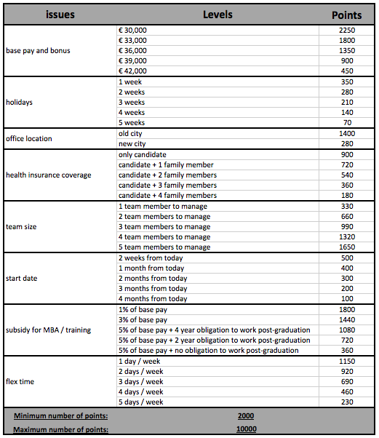
Thus, the maximum number of points you can get from this negotiation is 10,000 points and the minimum is 2,000 points. If you do not reach an agreement with the candidate you receive 0 points.
Your goal in this negotiation is to achieve as many points for yourself as possible from all 8 issues. Note that you can only sign the contract if you and M. Duarte agree on all 8 issues. Also note that it’s important to keep a good relationship with M. Duarte, who could become a valuable employee at Abere Company. Make sure you get a good deal for Abere Company while also building a good relationship with M. Duarte.
Please prepare for your meeting with M. Duarte now.

