
Role Play

The Castaways:
Role of the Stranded Student
06/2024-6918
This role play was written by Austin Dcosta, Byron Ascott-Evans, Emmanuele Benatti, Fernanda Antunes, Laura Foo, Sam Kaye, and Eric Sullivan, INSEAD MBA Alumni, and Rui Ling, Research Assistant, under the supervision of Martin Schweinsberg, Associate Professor of Organisational Behaviour at ESMT Berlin, Horacio Falcão, Professor of Management Practice of Decision Sciences at INSEAD, and Eric Uhlmann, Professor of Organisational Behaviour at INSEAD. It is intended to be used as a basis for class discussion rather than to illustrate either effective or ineffective handling of an administrative situation.
The authors gratefully acknowledge funding from the Hoffmann Institute.
To access INSEAD teaching materials, go to https://publishing.insead.edu/.
Copyright © 2024 INSEAD
Copies may not be made without permission. No part of this publication may be copied, stored, transmitted, translated, reproduced or distributed in any form or medium whatsoever without the permission of the copyright owner.

You and your friends are students studying in Singapore. You have recently learned how to dive and thought it would be an amazing experience to explore a tropical island over a weekend. One weekend, you decide to explore one of the most remote islands in Thailand: Koh Jum.
The only way to get to the island is with a ferry that leaves every two days. Since you know you have to be back at school on Monday, you plan to take the ferry that leaves on Sunday afternoon. Being back on Monday is particularly important because you have an accounting exam on Monday afternoon.
While on Koh Jum, you hear from other divers that there is a small “secret” uninhabited island named Ko Ilian nearby that has an excellent and unique looking, full of marine life, diving spot and can be easily reached by speedboat. You and your friends think this experience would really test your new diving skills so you pack your diving gear and hire a speedboat on Saturday morning to take you to this secret island.
The Complication
After leaving your personal belongings on the beach, you dive all morning on the secret island. By early afternoon, you make your way to the beach to wait for the speedboat to come and fetch you at the agreed time. The agreed pick up time comes and goes with no sign of the speedboat. Initially, everyone is calm but as the hours pass, you and your friends begin to panic.
As you go around the island, you confirm that it indeed has no human settlements. You have limited supplies (except for your personal belongings) and no meaningful shelter. You pick up the only phone you brought to the island and as expected the battery is dead. You look out at the beach for a couple of hours and not a single boat passes in the distance, let alone pass close enough by that allows you to grab their attention. It occurs to you that the driver of the speedboat is the only person who knows that you are there, and you have no idea what happened to him. Besides, no one at your school or from your family knows where you are.
The only thing that keeps you from panicking even more is that although this is a remote island, adventure divers visit it with some frequency. You are confident that within a day or two someone will pass by, but there is a small chance that it could be more, since after Monday the likelihood that divers will show up drops dramatically until the next weekend. You should be able to survive for a while on the island as fruit is plentiful and there is a stream with fresh water.
Your mind then jumps to the accounting exam and you realize that if you cannot make it back to Koh Jum for the Sunday ferry, you will miss the exam. Further, based on your classmates’ previous experiences with the school’s tough administration, the only way to avoid a failing grade for the accounting exam is to be there on Monday to take the exam. It is funny how in the middle of such difficult situations, some small issues manage to capture your attention…
The Idea
You and your friends are desperate. You can barely see Koh Jum as the tiniest black spot in the distance. You decide the only way to get from the secret island to Koh Jum is to build a raft and row back. You have spent a lot of time on small boats and estimate that if you can build a safe raft you would most likely get back safely to Koh Jum in no longer than 30 minutes.
In order to build a safe raft you would need at least four big logs (although more would be better), at least one rope to tie the logs together, and at least two small pieces of wood to serve as oars.
The Potential Solution
You start walking along the beach to find materials that you could use to build your raft. All of a sudden, there is a loud noise, almost like a growl, and a rustling in the bushes. Out steps a person dressed in very torn clothes, smelling like an animal and walking as if very comfortable with the surroundings. You say hello repeatedly but just receive a confused stare in return. As you attempt contact in several different languages, it is clear that this islander does not speak English nor any of the other languages you know. You are slightly afraid of this stranger, but you are also excited since apparently the islander has seemingly been living here on the secret island for a while now. The islander might be able to help you with the materials you need to build your raft. You will need to find a way to communicate with the islander to explain what materials you need and then negotiate for the materials. Your group of friends selects you to represent them in the negotiation with the islander.
Objects you need:
- Obtaining four big logs, one rope, and two small pieces of wood is fundamental because that is the minimum requirements for the raft.
- Each additional log is valuable because it can help you build a bigger and sturdier raft.
- Each additional rope is valuable because you could make the raft stronger.
- Each additional small piece of wood is valuable because extra oars might come in handy on the way to Koh Jum.
- You could really use the islander’s help building the raft.
Please fill out the “points you obtained” column below at the end of the negotiation to indicate which the islander’s items you obtained and how many points you received.
Things you need from islander | Value of obtaining the item
4 logs, 1 rope, 2 small pieces of wood* | 2,000pts
Islander’s help building the raft | 200pts
Each additional rope | 200pts
Each additional log | 100pts
Each additional small piece of wood | 50pts
Maximum value | 3,250pts
*only if all 7 items are collected
Personal Items You Could Trade
- Diving equipment – You are reluctant to trade your diving equipment (wetsuit, oxygen bottle, harpoon, mask, fins). Replacing it all would be very expensive.
- Clothes – Of course you would keep your swimming trunks and you would prefer to keep all of your clothes, but you are willing to trade them if that is what it takes to get back to Singapore in time for the accounting exam.
- Shoes – You would prefer to keep your shoes, but are definitely willing to trade them for raft-building materials.
- Money – Collectively you have $250 dollars in paper money which you would prefer not to give up in case you need it on the trip home. You have the option of giving the islander part of the money and keeping the rest for yourself. Each dollar you retain is worth 1 value point to you.
- Backpack – It would be much easier to keep your belongings safe if you have your backpack, but you would be willing to trade it.
- Sunscreen – One of you has already been sunburnt this weekend, so it is important to try to keep the sunscreen for the journey back given you will likely not have much shade.
- Solar Powered Radio – Your radio is old but it has sentimental value to you as it was a gift from your late uncle.
- Coke cans and beer bottles– You have kept your drinking containers from the weekend, since as a responsible citizen, even under distress, you will not leave them behind and trash the island. You were planning to recycle them away once you get to Koh Jum. It would be great to get rid of them earlier if possible.
- Thermos (not tradeable). You already have a thermos with fresh water for the trip in the raft and do not need your cans and bottles to transport water. You are unwilling to trade the thermos because you may need fresh water in an emergency.
- BCD (not tradeable). You are not willing to give your buoyancy control device (BCD) to the islander. It is quite valuable and a person not trained in using it properly could be seriously injured.
Your objective is to get back to Koh Jum by building a safe raft while trading the least valuable personal belongings possible to the islander.
Please fill out the “points kept” column at the end of the negotiation to indicate which of your personal items you kept and how many points you received.

Personal items you can trade | Value of keeping the item
$250 in cash | 250pts (1 pt per dollar)
Clothes | 100pts
Sunscreen | 100pts
Radio | 100pts
Diving equipment: wetsuit | 100pts
Diving equipment: oxygen bottle | 75pts
Diving equipment: harpoon | 50pts
Backpack | 50pts
Shoes | 50pts
Diving equipment: mask | 15pts
Diving equipment: fins | 10pts
Cans + beer bottles | -50pts
Maximum value | 900pts

If you give the Islander both your clothes and your sunscreen, subtract an additional 300 points from your final score since that means you greatly increase your chances of being seriously sunburnt.
If you do not obtain enough materials to build a raft, your only option is to stay on the island and hope to be rescued, which is unlikely to happen in a timely fashion. If you fail to build a raft, you must subtract 3000 points from your final score. However, in that case you can keep the collective points from all your personal belongings you did not trade.
**Important rules for this negotiation**
- Since you and the Islander do not speak the same language, during this negotiation, you cannot speak to your counterpart in any human language.
- During the negotiation, you can use gestures, body positions, and sounds (for example, grunts) to communicate with your counterpart.
- You can communicate by “drawing in the sand.” That means you can draw simple pictures on a blank piece of paper and share them with your counterpart, but absolutely no words.
- You cannot show your counterpart (the Islander) your written role materials
- You can show your counterpart the photos of the objects you can trade with (see subsequent pages, which you can detach from these role materials). You should physically exchange these photos with the Islander as if they were the real objects.
- You can reach additional shared understandings with the Islander. If, despite being unable to use words, you and your counterpart write the same shared agreement under “shared understandings” (see below) and this creates value for you, the instructor may add points to your final score.
- At the end of the negotiation, please add up your points total using the Points Payoff Tables on the next page and write your final score below.

Points Payoff Tables
Things you need from islander | Value of obtaining the item | Your score
4 logs, 1 rope, 2 small pieces of wood* | 2,000pts
Islander’s help building the raft | 200pts
Each additional rope | 200pts
Each additional log | 100pts
Each additional small piece of wood | 50pts
Maximum value | 3,250pts | (A)
*only if all 7 items are collected – if incomplete, count as 0pts.

Personal items you can trade | Value of keeping the item | Your score
$250 in cash | 250pts (1 pt per dollar)
Clothes | 100pts
Sunscreen | 100pts
Radio | 100pts
Diving equipment: wetsuit | 100pts
Diving equipment: oxygen bottle | 75pts
Diving equipment: harpoon | 50pts
Backpack | 50pts
Shoes | 50pts
Diving equipment: mask | 15pts
Diving equipment: fins | 10pts
Cans + beer bottles | -50pts
Maximum value | 900pts | (B)

Additional considerations | Value adjustment | Your score
If both Clothes + Sunscreen are given away | -300pts
If you do not obtain enough materials to build a raft | -3,000pts
Maximum value | 0pts | (C)

Your final score: add (A) + (B) + (C) =

Note: The subsequent pages should be printed single-sided. The pictures can be cut out along the dotted lines for trading.
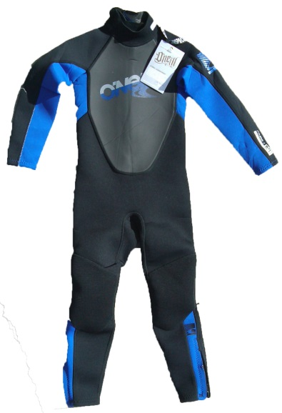 | 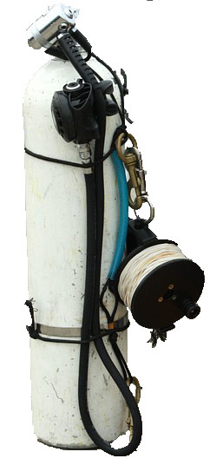
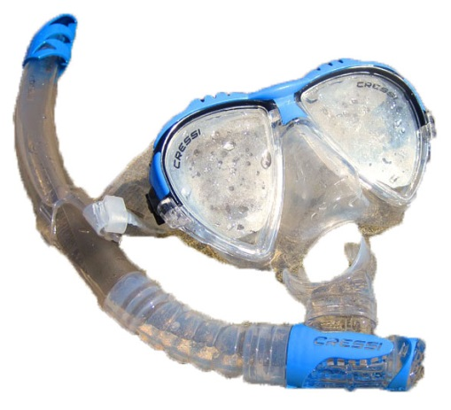 | 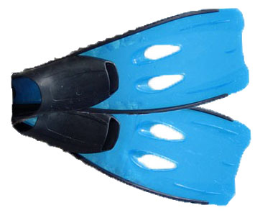
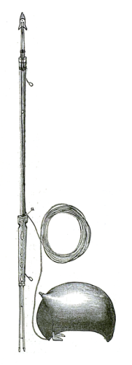

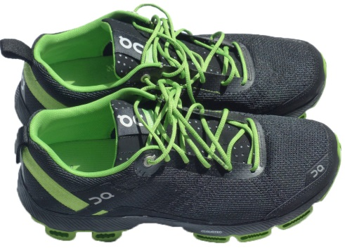 | 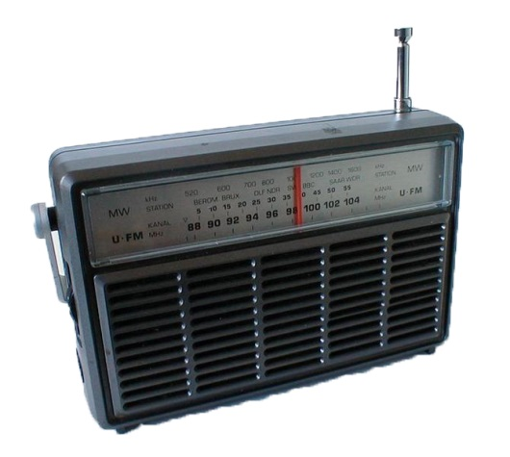
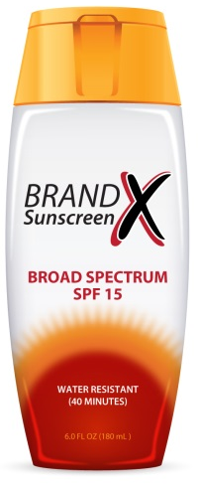 | 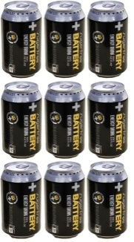  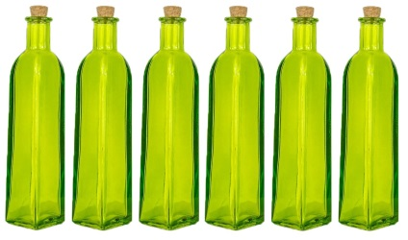
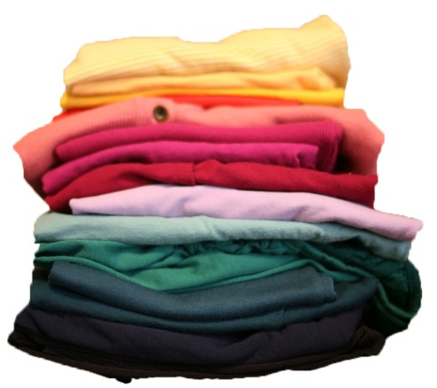 | 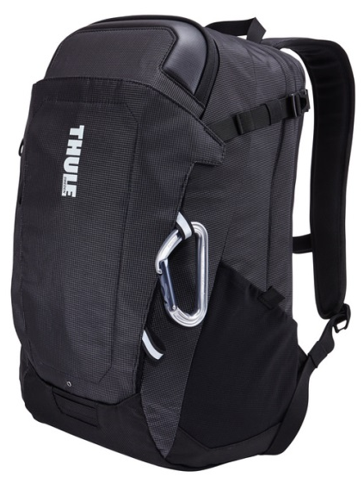

 | 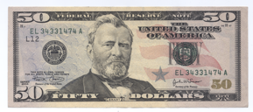
 | 