
Role Play

The Castaways:
Role of the Islander
06/2024-6918
This role play was written by Austin Dcosta, Byron Ascott-Evans, Emmanuele Benatti, Fernanda Antunes, Laura Foo, Sam Kaye, and Eric Sullivan, INSEAD MBA Alumni, and Rui Ling, Research Assistant, under the supervision of Martin Schweinsberg, Associate Professor of Organisational Behaviour at ESMT Berlin, Horacio Falcão, Professor of Management Practice of Decision Sciences at INSEAD, and Eric Uhlmann, Professor of Organisational Behaviour at INSEAD. It is intended to be used as a basis for class discussion rather than to illustrate either effective or ineffective handling of an administrative situation.
The authors gratefully acknowledge funding from the Hoffmann Institute.
To access INSEAD teaching materials, go to https://publishing.insead.edu/.
Copyright © 2024 INSEAD
Copies may not be made without permission. No part of this publication may be copied, stored, transmitted, translated, reproduced or distributed in any form or medium whatsoever without the permission of the copyright owner.

You come from a poor fishing family who speaks a unique dialect of a rare language that only very few people seem to speak. You never married and chose to live an isolated existence as a hermit on a deserted island near Koh Jum for the rest of your life. You are used to a peaceful life of fishing and prefer to avoid the outside world, thus you never attempted to learn any other language then your mother tongue. Besides, your only exposure to others is mostly from a distance, when you see the ferries and speedboats coming and going to Koh Jum.
The Invaders
Your peaceful life has become less peaceful since speedboats have begun bringing strange people to your island. Even though these strange people do not spend much time on your island, you are irritated that they keep coming here. They affect your peaceful life and disturb the natural beauty of the island. You have often observed these strange people but cannot understand what they are doing or saying which makes you fearful. As a result, you normally avoid them and hide whenever they are around.
While you are coming back from your regular morning fishing trip, you encounter a small group of these strange people on your beach. They are speaking loudly in a language you cannot understand. They keep pointing at you, their personal belongings and at Koh Jum and are doing something that looks a bit like a dance.
The Idea
You are not sure what to do. After staring at them for a while, you notice they have some intriguing objects. Despite their constant babbling and confusing language you do not understand, you are able to understand what each object is for. If you could find a way to communicate with the strangers, perhaps you could exchange some of your resources for their interesting belongings. One of them steps forward from the others and appears to be acting as their representative to you.
Objects Belonging to the Strangers That You Would Be Interested In
- “Diving Equipment” –You have seen the strangers use these weird water clothes and stay under water for quite a while. The longer you can stay down, the more fish you can get.
  - You would especially like to have the stranger’s mask and wetsuit so you can see better underwater and keep your body warm when you are beneath the surface.
  - Their fins would help you expend less energy while swimming.
  - You are already skilled at catching fish with nets, but their harpoon would still be useful to you.
  - Their oxygen tank is not very valuable to you because you know such air tanks can only be used once without being refilled.
- “Clothes” – Occasionally you have gotten cold on the island and wish you had more clothes to cover your body. However, this is quite rare and you are not in desperate need of more clothing.
- “Shoes” –Your feet are normally very cut and sore after a day of fishing and hunting. You have gotten used to this over time, but would prefer to prevent the constant pain with a nice pair of footwear.
- “Money” – Having some money stacked away may not be a bad idea so that if you ever run out of food, you could buy some from these strangers that keep on coming to the island. From your life before becoming a hermit you are familiar with the value of the strangers’ currency. Each dollar you obtain from the strangers is worth 1 value point to you.
- “Backpack” – It would make your life much easier if you had something to carry your belongings around in.
- “Sunscreen” – It would be great to have some sun blocking cream as you are constantly getting burned in the sun.
- “Solar Powered Radio” – Although you have no desire for contact with the outside world, it would be nice to have this device to listen to music with.
- “Cans and bottles” – You are very excited to see they have some empty bottles and cans. You currently use coconuts to store water, but wish you had more items that could store fresh water for longer.
Please fill out the “points obtained” column at the end of the negotiation to indicate which of the stranger’s belongings you obtained how many points you received.
Things you need from strangers | Value of obtaining the item
Backpack | 300pts
Shoes | 300pts
Cans + beer bottles | 300pts
$250 in cash | 250pts (1 pt per dollar)
Sunscreen | 200pts
Radio | 100pts
Diving equipment: wetsuit | 100pts
Diving equipment: mask | 75pts
Clothes | 50pts
Diving equipment: fins | 40pts
Diving equipment: harpoon | 25pts
Diving equipment: oxygen bottle | 10pts
Maximum value | 1,750pts
Resources of Yours That You Could Trade
Before going further, you stop and think about what you have that might be of interest to the strangers. You are planning to expand your shelter and therefore you have compiled a pile of five large wood logs, five smaller pieces of wood, five ropes you made out of local plants, and five large stones. Importantly you are in a small island, which means that you do not have unlimited resources and would like to give away as few items as possible as it was a lot of hard work for you to accumulate them.
You also would like these strangers to leave your island as soon as possible and go back to your isolated life. So, if you could secure more objects by doing so, you would be willing to help them put the raft together and indicate the best route out of the island to avoid the tricky currents. This would cost you no points since having lived in these islands your whole life and you are highly experienced at building and sailing rafts in these tricky waters.
Your objective is to obtain as many of the strangers’ belongings items as possible while permanently losing as few of your own resources as possible.
Please fill out the “points kept” column at the end of the negotiation to indicate which of your personal items you kept and how many points you received.
Resources you can trade | Value of keeping the item
Ropes (x5) | 50pts/item
Large stones (x5) | 20pts/item
Logs (x5) | 20pts/item
Small pieces of wood (x5) | 10pts/item
Maximum value | 500pts

If you do not reach a deal with the strangers, you keep all your resources and your final score is therefore 500 (the value points for all your wood, rope, and stone combined).
**Important communication rules for this negotiation**
- Since you and the Strangers do not speak the same language, during this negotiation, you cannot speak to your counterpart in any human language.
- During the negotiation, you can use gestures, body positions, and sounds (for example grunts) to communicate with your counterpart.
- You can communicate by “drawing in the sand.” That means you can draw simple pictures on a blank piece of paper and share them with your counterpart.
- You cannot show your counterpart your written role materials.
- You can show your counterpart the photos of the objects you have available to trade (see subsequent pages, which you can detach from these role materials). You should physically exchange the pages with the photos with your counterpart as if they were the real objects.
- You can reach additional shared understandings with the strangers. If, despite being unable to use words, you and your counterpart write the same shared agreement under “shared understandings” (see below) and this creates value for you, the instructor may add points to your final score.
- At the end of the negotiation, please add up your points total using the Points Payoff Table and write your final score on the next page.

Points Payoff Tables
Things you need from strangers | Value of obtaining the item | Your score
Backpack | 300pts
Shoes | 300pts
Cans + beer bottles | 300pts
$250 in cash | 250pts (1pt per dollar)
Sunscreen | 200pts
Radio | 100pts
Diving equipment: wetsuit | 100pts
Diving equipment: mask | 75pts
Clothes | 50pts
Diving equipment: fins | 40pts
Diving equipment: harpoon | 25pts
Diving equipment: oxygen bottle | 10pts
Maximum value | 1,750pts | (A)

Resources you can trade | Value of keeping the item | Your score
Ropes (x5) | 50pts/item
Large stones (x5) | 20pts/item
Logs (x5) | 20pts/item
Small pieces of wood (x5) | 10pts/item
Maximum value | 500pts | (B)

Your final score: add (A) + (B) =

Note: The subsequent pages should be printed single-sided. The pictures can be cut out along the dotted lines for trading.

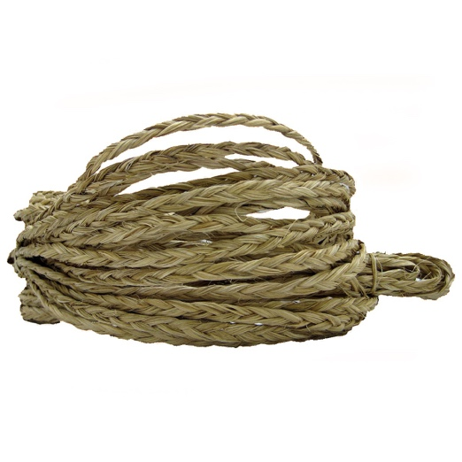

Large piece of wood  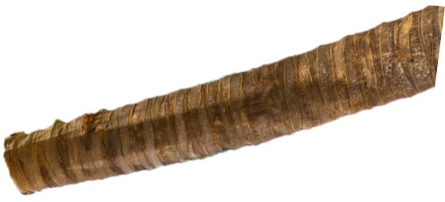 | Large piece of wood
Large piece of wood | Large piece of wood
Large piece of wood

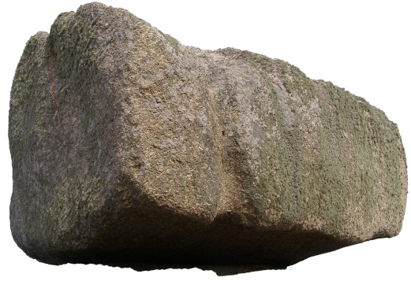

Small piece of wood  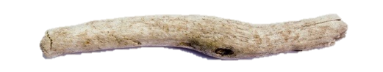 | Small piece of wood  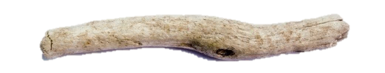
Small piece of wood | Small piece of wood
Small piece of wood

