
Role Play

Jubilee:
Role of the Jubilee Organizer
06/2024-6912
This role play was written by Matthijs De Kempenaer, Umair Chishti, Jakub Kasperczyk, Shantanu Jain, and Rodolfo Pelitz, INSEAD MBA Alumni, and Warren Tierney, Postdoctoral Research Associate at INSEAD, under the supervision of Martin Schweinsberg, Associate Professor of Organisational Behaviour at ESMT Berlin, Horacio Falcão, Professor of Management Practice of Decision Sciences at INSEAD, and Eric Uhlmann, Professor of Organisational Behaviour at INSEAD. It is intended to be used as a basis for class discussion rather than to illustrate either effective or ineffective handling of an administrative situation.
To access INSEAD teaching materials, go to https://publishing.insead.edu/.
Copyright © 2024 INSEAD
Copies may not be made without permission. No part of this publication may be copied, stored, transmitted, translated, reproduced or distributed in any form or medium whatsoever without the permission of the copyright owner.

You are Willem de Vries, a 5th year Civil Engineering student in the city of Hoogeveen in the Netherlands, close to completing your master’s degree. You’ve been asked by your alma mater, the prominent and well funded Hoogeveen University of Technology, to organize a Jubilee, which is held once every 5 years and is the highlight of most students’ time at the university. In return for organizing the Jubilee, you will receive a one-year scholarship. The Jubilee will have 30 thousand visitors including many alumni from the university. With a budget of EUR 2 million, it is a highly publicized event. The event will last for two weeks over the summer, with many different events, including a big gala ball, and many other fun-filled activities. Most of the festivities will be held at the specially built grounds. Previous teams have had trains suspended between buildings to serve as airbridges or had jet fighters fly over for the opening ceremony, so expectations are very high!
Last year’s Jubilee team has already arranged a preliminary location for this year through the municipality, who own a local vocational school in Hoogeveen, the PC Hooft Lyceum, that is a perfect setting. The PC Hooft Lyceum will be empty at the time of the event for the summer break. Throughout the preceding months, teams of students from your Hoogeveen University of Technology will build bars, a café, and a full-fledged restaurant including a professional kitchen, for the Jubilee in the PC Hooft Lyceum building. To help you with the construction, there is a team of 8 expert students, known as the “Technical Committee”, who will help you construct the new structures for the Jubilee. After the Jubilee your workers can demolish all of the new structures you build, and restore the previous structures just as they were in time for the PC Hooft Lyceum to reopen for classes.
Full of enthusiasm, you are ready to start the planning. Given the shortage of student helpers from the Hoogeveen University of Technology, you believe up to 10 pupils of the vocational training-oriented PC Hooft Lyceum school could be recruited to work on the construction projects for the Jubilee as interns, providing them with work experience and you with extra workers. The Jubilee team will construct the Jubilee grounds, but the vocational school will need to use the building again when it reopens after the summer break. The municipality leaves it completely up to you and the school head from the PC Hooft Lyceum to come to some sort of agreement on how to manage this.
Although the municipality has approved in principle, the PC Hooft Lyceum school is still the legal user of the property and has the right to ask for rent from the Jubilee organizers. If they are offered what they regard as inadequate payment, the PC Hooft Lyceum could in theory refuse to host the Jubilee. Honestly, however, this would be ridiculous since the vocational school is not even using their building during the summer, such that any payment you give them is basically free money for them.
A meeting between you and the head of the PC Hooft Lyceum, Liselotte Smit, has been set up to agree on a price for the temporary use of the school for the Jubilee. You spoke with your treasurer, Marietje, and she has allocated a maximum budget of EUR 150 thousand for rent to the PC Hooft Lyceum, but that is the absolute maximum of money she can free up for this. However, anything less than EUR 150 thousand would save money for extra activities and performing artists during the Jubilee, which you are very keen on as you are responsible for the music during the 2 weeks. In addition to a specific area on the ground floor, you need at least a floor of classrooms and 2 gymnastic halls on the level above (see Appendix). Ideally you would also like to remove the current school Auditorium and use the space for the Jubilee festivities. Your skilled workers can easily move the entire Auditorium (both the walls and the internal structures) of the PC Hooft Lyceum to a new temporary location in the far corner of the building, then put the entire Auditorium back in its original location after the Jubilee (see Appendix).
In case you fail to reach an agreement with the PC Hooft Lyceum school head, your only alternative is to hold the Jubilee inside the library of the Hoogeveen University of Technology itself—a poor location and also certain to raise the ire of your university’s administrators. Having effectively failed in your role as organizer, you will not receive the previously allocated scholarship and your reputation among students and alumni of the Hoogeveen University of Technology will be severely damaged.
After the negotiation, please fill out the outcome form at the end of the School Head’s role description.

Appendix
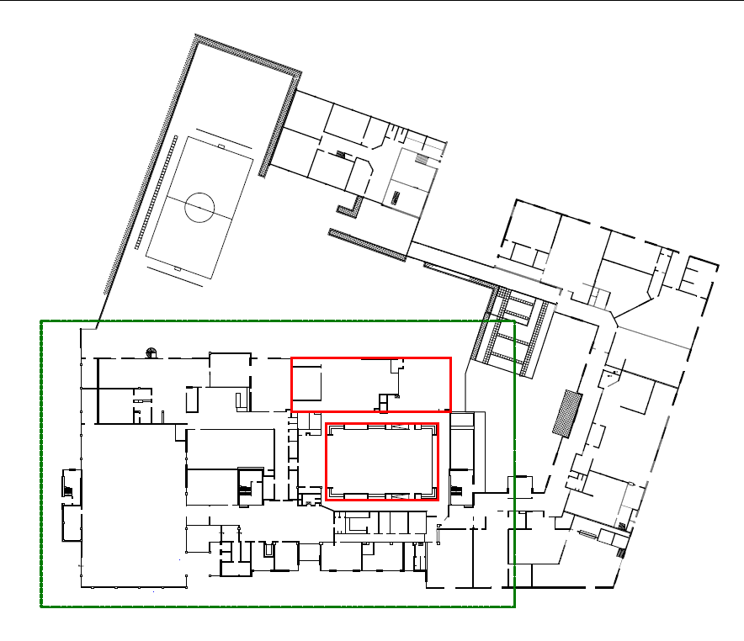
Planned new restaurant
Current Auditorium
Auditorium Structures (temporary)
Ground floor of PC Hooft Lyceum school, with dotted lines indicating the area planned for use by Jubilee. The far right corner indicates the area where you intend to temporarily move the auditorium during the Jubilee.

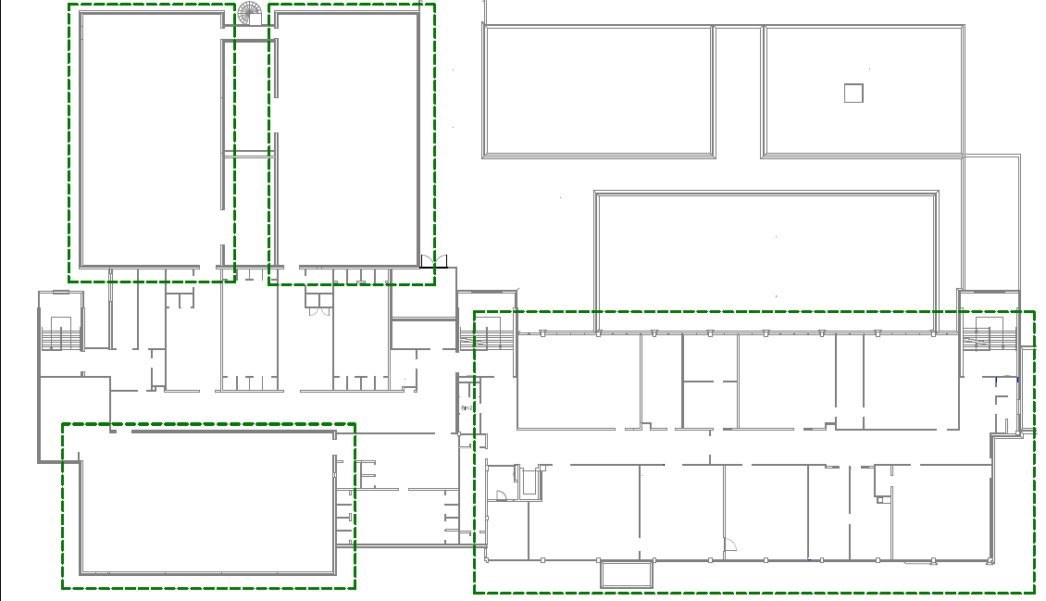
Gymnasium Hall 1
Gymnasium Hall 2
Gymnasium Hall 3
Floor of classrooms for bars
Floor above the ground level of the PC Hooft Lyceum school, with further desired locations for use during the Jubilee marked with dotted lines.

