
Role Play

Jubilee:
Role of the School Head
06/2024-6912
This role play was written by Matthijs De Kempenaer, Umair Chishti, Jakub Kasperczyk, Shantanu Jain, and Rodolfo Pelitz, INSEAD MBA Alumni, and Warren Tierney, Postdoctoral Research Associate at INSEAD, under the supervision of Martin Schweinsberg, Associate Professor of Organisational Behaviour at ESMT Berlin, Horacio Falcão, Professor of Management Practice of Decision Sciences at INSEAD, and Eric Uhlmann, Professor of Organisational Behaviour at INSEAD. The authors thank Martina Chiari for her feedback on this role. It is intended to be used as a basis for class discussion rather than to illustrate either effective or ineffective handling of an administrative situation.
To access INSEAD teaching materials, go to https://publishing.insead.edu/.
Copyright © 2024 INSEAD
Copies may not be made without permission. No part of this publication may be copied, stored, transmitted, translated, reproduced or distributed in any form or medium whatsoever without the permission of the copyright owner.

You are Liselotte Smit, the head of the PC Hooft Lyceum, a vocational training-oriented school in the city of Hoogeveen, the Netherlands. Your school is going through a difficult period financially. At the same time, the buildings are getting really old and due to the lack of funding the renovation discussions over the last several years have become a huge headache. You have been appealing to the municipality, aiming to obtain a respectable budget to improve the building and training facilities for your students, without much success.
Recently, it was proposed by the municipality that the PC Hooft Lyceum building could be used to host the Jubilee of the nearby Hoogeveen University of Technology. The Jubilee is held once every 5 years and will have 30 thousand visitors including many alumni from the Hoogeveen University of Technology. It lasts for 2 weeks over the summer, with many different activities, including a big gala ball. The plan is for most of this to be held at a specially built grounds within the PC Hooft Lyceum building itself. You find it outrageous that wealthy universities are able to waste extravagant sums on such frivolities (you have heard that Jubilee expenses can run into the millions), while small vocational schools like yours lack proper facilities for your students to learn in. However, the rent paid by the Jubilee organizers could help solve your financial headaches.
When you met with the municipality the last time, a number of issues were discussed. This included the new electricity contract, as well as the funds for a new training restaurant with a professional kitchen in your vocational school, which a supplier estimated at EUR 50 thousand, but for which the municipality has no budget to provide you.
During the meeting you found out that the municipality has already made a preliminary commitment to the Hoogeveen University of Technology for the Jubilee and that you now need to sort it out with the Jubilee organizers. Although you could in principle refuse to host the Jubilee if the payment offered by the organizers is inadequate, this would put you in a very difficult situation politically with the municipality, on which you are heavily dependent. When you last spoke to the Mayor of Hoogeveen, you could tell that the Jubilee was very important to him and that you would lose all goodwill with him if you do not come to an agreement. You hope to agree with the Jubilee organizers on a price to let them use your school building, as you need the funds and want to keep your good relationship with the municipality.
Not long after the meeting with the municipality, your facility manager looks for you to discuss moving the school Auditorium to another wing of the building, to reduce energy use. It’s an excellent proposal that would help solve your electricity use problems. However, you do a quick calculation with her, and it would take a team of five about two weeks to relocate the Auditorium to the new part of the building. This would be another EUR 20 thousand out of your budget, which is already very tight for the year. You tell the facility manager that you don’t have the money right now and you decide to keep the Auditorium where it is for the time being.
As if that was not disappointing enough, you receive a call from a major construction company cancelling 10 internships you had arranged for a group of your students for the coming months. That is a major problem as well since you now also have to figure out another internship program for these students, a key part of their vocational training. This complication is taking a lot of your time and attention since it seems hard to find another option that will cost you less than the EUR 30 thousand you had initially estimated for this.
Completely overwhelmed with all the problems you are facing, you have a meeting lined up with Willem de Vries, the lead Jubilee organizer, to discuss the price of renting your school to them for use during the Jubilee. The minimum acceptable price, given the valuable space you are offering, would be EUR 200 thousand. This is the standard fee anyone wishing to rent the space must always pay; given your responsibilities as School Head you cannot agree to less since you would then be charging below what the PC Hooft Lyceum itself pays in rent and maintenance costs. If you were to accept a contract value below EUR 200k, the PC Hooft Lyceum would be effectively using taxpayers’ money to pay for the Jubilee. The Hoogeveen University of Technology is a comparatively better funded institution and they can afford to pay your cash-strapped vocational school what is fair.
In terms of spaces, the PC Hooft Lyceum can offer the Jubilee organizers space on the ground floor of the West Wing, as well as 1 floor of classrooms and up to 3 gymnasium halls on the floor above. Of course, the Jubilee organizers must clean up all the trash and remove any and all new non-useful structures they put in place for their ridiculous party before they leave. The municipality leaves it completely up to you and the Jubilee organizer to come to some sort of agreement on how to manage this.
Your alternative is to rent the entire PC Hooft Lyceum building for a summer science fair that has offered you EUR 200 thousand. The science fair would require the entire school grounds at the same time as the Jubilee, thus you don’t have the option of hosting both the Jubilee and the fair. Although in terms of your values a science fair seems a more worthy use of your school grounds, rejecting the Jubilee would create huge political problems with the municipality which has already made a preliminary agreement with the Jubilee organizers from the Hoogeveen University of Technology. Politically, this option may be out of the question, but you could still use the competing offer from the science fair as a starting point for the negotiation, to see whether you can get a financially more interesting proposal from the Jubilee.
After the negotiation, please fill out the outcome form.

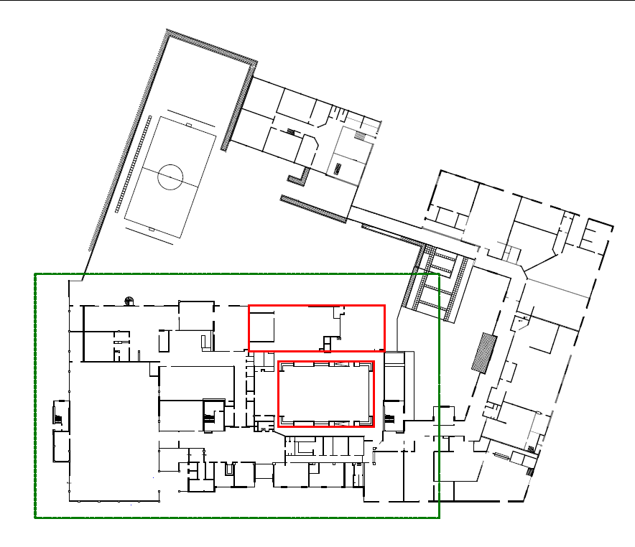
Appendix
Current Auditorium
Planned new location for auditorium
Planned new restaurant
Ground floor of PC Hooft Lyceum school, with dotted area planned for use by Jubilee. You hope to keep the Jubilee confined to specific areas of the building, marked here and on the next page. Also indicated is where you hope to eventually build a new restaurant for the school and move the auditorium to a new location from its current one.

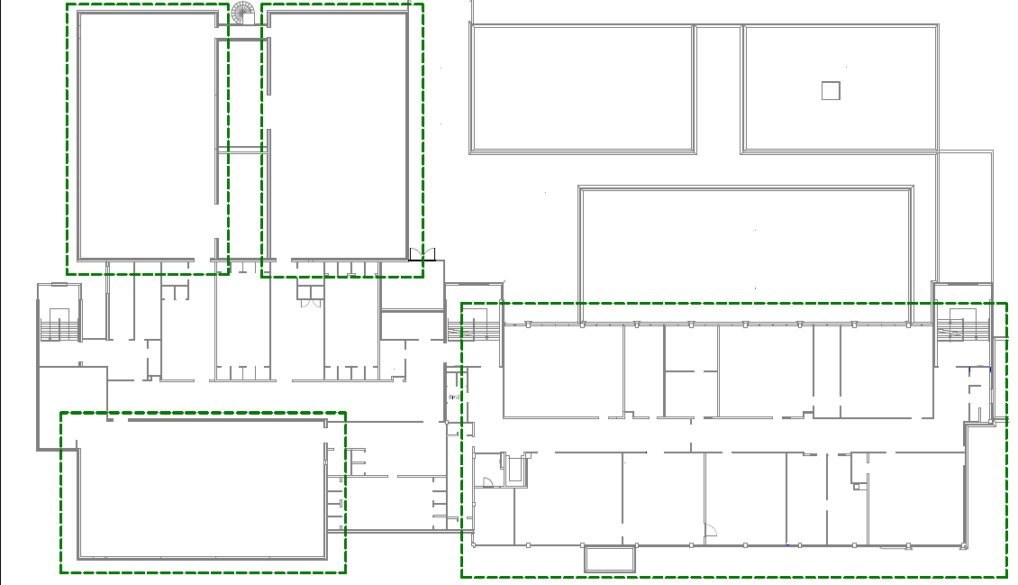
Floor above the ground level of PC Hooft Lyceum school, with preferred locations for the Jubilee marked with dotted lines. You can offer the Jubilee organizer one floor of classrooms and up to three gymnasium halls on this level of the building.
Gymnasium Hall 1
Gymnasium Hall 2
Gymnasium Hall 3
Floor of classrooms

