
Role Play

The Art Case:
Role of the Museum Director
06/2024-6905
This role play was written by Martin Schweinsberg, Associate Professor of Organisational Behaviour at ESMT Berlin, Horacio Falcão, Professor of Management Practice of Decision Sciences at INSEAD, Warren Tierney, Postdoctoral Research Associate at INSEAD and Eric Uhlmann, Professor of Organisational Behaviour at INSEAD. It is intended to be used as a basis for class discussion rather than to illustrate either effective or ineffective handling of an administrative situation.
To access INSEAD teaching materials, go to https://publishing.insead.edu/.
Copyright © 2024 INSEAD
Copies may not be made without permission. No part of this publication may be copied, stored, transmitted, translated, reproduced or distributed in any form or medium whatsoever without the permission of the copyright owner.

You are the museum director at the National Arts Museum in London (“NAML”). A little over two years ago, you took on the job with the mission to maintain the museum’s stellar global reputation while also saving costs. Thus your challenge is to walk the thin line of hosting successful and leading events to promote the arts locally and globally while bringing the NAML’s finances out of the red and back into being a sustainable ongoing concern. This has proven a difficult challenge, but you have the resilience to know that this is a work for the patient and luckily you have the full support of the Board of Trustees (BoT).
A couple of months into the job you realized that the museum curators have routinely overpaid for new art pieces. These art pieces have helped shape the museum’s reputation as a global arts powerhouse, but the museum has been a price-taker and has not been negotiating prices at all. To stop this bleeding, a couple of years ago you took on the responsibility to acquire any artwork with an asking price above £100k, where your direct intervention can create a bigger positive impact on the NAML’s finances.
An important exhibition on South American art is coming up and you are personally managing the potential acquisition of a key art piece for this exhibition: “Hilario” (also potentially translated as “Hilarious” in English) by Hilario Gomez. South American art is the trendiest thing right now and so the potential is quite high. However, failure to produce a crowd-pleasing exhibition could deflate expectations and reduce attendance to this and future exhibitions until the end of the year. For art exhibitions to be successful you either need a famous name or two, or some really stand-out pieces that people will flock in to see, preferably both. As such, you need one more art piece that could really attract the attention of the international arts world and you won’t settle for anything less than a spectacular piece of art such as “Hilario”, since it is guaranteed to attract a big crowd. Even if, Hilario Gomez is not that well known yet and his name does not yet pull crowds, this may actually work in your favor as you may be able to bargain to get “Hilario” very cheap. After all, if “Hilario” comes at too high a cost, it may cancel out the additional profits it may bring in.
If all the stars line up, including “Hilario”, you expect your South American Contemporary Art exhibition (SACA) to attract half a million paying visitors over the three-month exhibition period. It already has 75k advance tickets sold – almost as many as the most recent blockbuster exhibition of Dalí in another museum, which pulled in 750k visitors. All 5k guided tours have already sold out. The entry ticket will cost £10.00 and the guided tours + ticket combo, £20.00. Raising price tickets has a great negative impact on attendance, while lowering prices has very little positive impact. Unfortunately, all advance purchase tickets are refundable and history has proven that refunds are highly sought, if the opening day generates disappointing reviews. If the house is full, F&B and the Museum shop are expected to bring in an additional £600k.
Luckily, the NAML is in a city with an extremely high demand for museum exhibitions, making sound investments almost certainly a success. A successful exhibition could attract 30% of its attendance from non-local visitors alone and up to 50% if it turns out to be a blockbuster.
The SACA exhibition is expected to take about 10,000 square feet at a cost of £250 per square foot of which 20% is dedicated to research, design and exhibit development. It is planned to present 200 of South America’s most definitive contemporary paintings and sculptures as well as new research and scholarship reassessing the unique contributions of South American art to the world and its already pervasive legacy despite its young history. You are investing greatly in educating the public on the history and the context of South American art, thus a part of your extra costs are going into promoting the story of a selected few representative artists, their creative process, etc. In the past, this extra investment has proven to help the public better empathize and understand the artworks, thus better appreciating the exhibitions.
You are well aware that the average exhibitions take about 6,000 square feet with fewer pieces (125 paintings and sculptures) at a cost of £225 per square foot of which 17% is dedicated to research, design and exhibit development. So if need be, you could scale back your event, starting with the extra investment for the contextualization, videos and history of South American art. However, the impact on the potential success of the exhibition would be uncertain at best. After all, you decided to go bigger as this is a promising exhibition and South American contemporary art is a well-regarded investment right now.
The SACA exhibition cost includes exhibition lighting, area walls, floor and wall coverings, specialty electrical requirements and exhibit costs, but does not include other fixed costs or the cost of the art itself. The SACA exhibition attendance revenues are naturally expected to cover the NAML total fixed costs of £1.2M for the period of the exhibition. More importantly, you are expecting some revenue “leftover” of at least £500k to amortize the large NAML debt, fundamental for the museum’s survival.
Besides, you managed to secure a lot of the art through loans (around 1% - 5% of acquisition value per exhibition), some in consignment and even a few pieces as solicited gifts, bringing your total art cost for the SACA exhibition so far to an average of only £5k per artwork. It required significant amounts of begging on your behalf and even personal visits by your curator to private collectors and galleries around the world, but the results so far have been rewarding your efforts.
Since the museum has also been lacking on South American art and has been greatly criticized for this shortcoming, your intention is to buy a high-profile South American artwork of outstanding quality for the exhibition and then leave it permanently on display in order to complete the museum’s international collection. It would be ideal to combine the acquisition of this piece for both the exhibition and the permanent collection, since a high-profile acquisition could create an extra media splash for the SACA exhibition and bring extra attention to the growth of the South American art permanent collection, which in turn could create a new opportunity for soliciting monetary donations or even an endowed fund to increase this section of the museum even further at no further costs to the museum.
The process for acquiring new art has always been meticulous and time-consuming, since guaranteeing that you are only acquiring quality art is paramount. Thus, curators constantly scan the markets for worthy items, often travelling to see the artworks firsthand. Then, a committee composed of representatives from different curatorial departments review acquisitions, either periodically or upon request from the curator, votes and then makes recommendations to the BoT. Upon approval from the BoT, the curator receives a mandate to acquire the approved pieces. Until two years ago, such approvals gave no price parameters. For all practical purposes, the curator had an open mandate to acquire the artwork with only an expectation for the best possible prices, which you verified then was not the case.
In order to increase the negotiation discipline of the museum purchasing process and thus help reduce the NAML debt, for two years now you created a new acquisition process where the committee’s and the BoT’s combined expertise of the art market is also used to define pre-approved prices for the curator. Since then curators have negotiated much more aggressively and even you have secured some surprising bargains on the more expensive artworks. The committee and the BoT really liked the new process and have proven to dislike having to review prices up. They have only once done so, when indeed they were convinced of having mispriced the artwork in the first place. While as the director you have leeway on how to structure your deals, when it comes to acquiring artworks, you are performing as a curator and your performance will be similarly measured by your success in acquiring the piece and by how little you paid for it.
The NAML has three criteria for acquiring art permanently: a) it needs to be of overwhelming quality (i.e., raise or at least maintain the overall artistic value of the collection); b) complement an existing collection (as opposed to being a single piece dissociated from everything else in the NAML); and c) add to the attractiveness of the museum’s collection (i.e., raise attendance). Despite the doubts around the perceived quality of contemporary art being the result of fads, the Hilario Gomez’ “Hilario” was seen by the committee and the BoT as fulfilling all three criteria and thus approved for acquisition. They provided you with their expert evaluation of “Hilario” value at a range of £350k – £450k. Considering the expected revenues of the SACA exhibition to help fund this acquisition, they gave you that range as your mandate to acquire the artwork.
Your mandate leaves you a bit distressed, since you know that the art market is really hot right now, as if in a bubble, and thus overpriced, and while it is likely to correct itself soon (Exhibit 1), this context does not help this particular negotiation. For now, you expect the SACA exhibition to generate £500k or more of surplus after accounting for everything else and you much rather spend an extra £100k to 150k on “Hilario” if it means securing a successful event. You could even go beyond the £600k if you really needed as you could try to find more money somewhere else. However, you would need at least one very good reason to pay above the BoT’s mandate, otherwise you will fail to explain your rebellious act to the BoT.
Previously the museum would often buy art from the To-map art gallery in New York. To-map is one of the biggest art galleries in the world and has supplied you with art that doesn’t necessarily turn heads but is generally recognized as being high quality. Recently however, To-map galleries annoyed you when they pulled out of a deal in the last minute and you later found out that they sold the art piece you were pursuing to a private collector. So not only they have been taking advantage of your curator’s lack of negotiation skills to sell paintings to the NAML at their full price, they are not even giving you priority treatment when you need to set up an important exhibition.
You would rather not deal with To-map again if you can avoid it. To-map has another painting from Hilario Gomez at £350k, which you could probably negotiate closer to £300k. This other painting is a quality art piece like all pieces from Gomez, but nothing close to “Hilario” and probably not at the level you need for it to be the centerpiece of the SACA exhibition. As you learned early in your career in the art industry, it is better to have the best painting from a good painter than a bad painting from a master.
You therefore recently contacted the Galerie C@stet in Paris’ 4th district. The whole art world is very excited about Galerie C@stet and it is attracting a lot of attention. Galerie C@stet represents Hilario Gomez and carries “Hilario”, which you hope to buy. Galerie C@stet has made lots of progress over the last few years and would be the perfect supplier of South American art for the NAML in the future. The owner is globally recognized as an expert on South American art, and especially art from Argentina, Chile, Brazil, and Peru. One of the main concerns in the contemporary art world is the authenticity of the artworks, which can be very easy to fake. Despite the reputation of Galerie C@stet, you would want to check with Hilario Gomez himself to verify the authenticity of “Hilario”, if you close the deal. Authenticity is a non-negotiable, since buying a fake would ruin the NAML’s reputation.
The challenge is that “Hilario” is going to be expensive and cost much more than other paintings from Hilario Gomez or other contemporary South American artists, such as the ones you saw at To-map galleries. You don’t know by how much you can get Galerie C@stet to lower their price, but you are confident that you can use the stellar reputation of the NAML to your advantage. After all, an association with the NAML and the exposure you are willing to offer to “Hilario” would raise the value of all pieces from the same artist or within the same movement, which could greatly benefit Galerie C@stet and all of its South American artists by association.
Remember that no matter what other arrangements you may make with Galerie C@stet, at the end of the day, the BoT and the committee will measure your success by your ability to acquire “Hilario” and for the best possible price.
If successful in your acquisition, you would prefer to give the credit for acquiring “Hilario” to your curator, who was the one who actually found the artwork in the first place. So in closing the deal, you would ask Galerie C@stet to put the curator’s name (J. Williams) in the invoice so that credit can be officially given.
Prepare for your negotiation with the Gallery owner.

Exhibit 1
The Museum Director’s Forecast of the Art Market
Scenario 1: “We are in a bubble and the market will correct itself!”
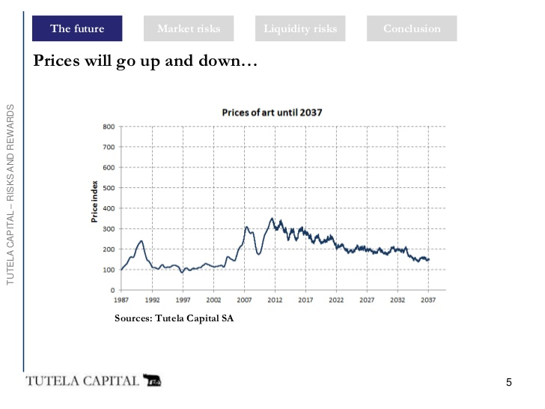
T-20 T-15 T-10 T-5 T0 T5 T10 T15 T20
Years
Based on http://www.slideshare.net/TEFAF/tc-presentation-tefaf (accessed September 2016)

Scenario 2: “We are at the top of a cyclical market!”
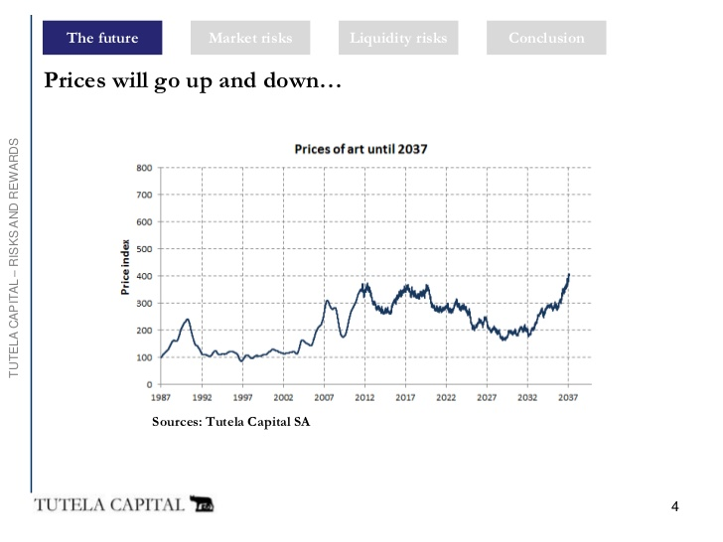
T-20 T-15 T-10 T-5 T0 T5 T10 T15 T20
Years

Based on http://www.slideshare.net/TEFAF/tc-presentation-tefaf (accessed September 2016)

