
Role Play

The Art Case:
Role of the Gallery Owner

06/2024-6905
This role play was written by Martin Schweinsberg, Associate Professor of Organisational Behaviour at ESMT Berlin, Horacio Falcão, Professor of Management Practice of Decision Sciences at INSEAD, Warren Tierney, Postdoctoral Research Associate at INSEAD and Eric Uhlmann, Professor of Organisational Behaviour at INSEAD. It is intended to be used as a basis for class discussion rather than to illustrate either effective or ineffective handling of an administrative situation.
To access INSEAD teaching materials, go to https://publishing.insead.edu/.
Copyright © 2024 INSEAD
Copies may not be made without permission. No part of this publication may be copied, stored, transmitted, translated, reproduced or distributed in any form or medium whatsoever without the permission of the copyright owner.

You are the owner of the Galerie C@stet in Paris’ 4th district. It has taken you years of hard work to build up your gallery to what it is today, a small but increasingly successful and recognized art gallery that supplies museums and private collectors all over the world with original pieces of art.
You are about to negotiate with the director of the National Arts Museum London (“NAML”). The NAML is one of the most prestigious galleries in the world but they have recently become keen on securing really low prices for the art they’re purchasing. The museum director seemed excited about the art in your gallery but already expressed reservations about price when the two of you chatted earlier over the phone. And yet, this negotiation is probably important for the NAML since normally it is the curator, not the director, who acquires artworks.
In any event, several months ago, the museum director contacted you about an exhibition the NAML is developing on modern South American art. You sent them an overview package with pictures of the art and their details, history of the artist, and description of your pieces that could be the perfect fit for their exhibition. You haven’t heard anything back from them after you had sent in this overview and you figured that they were no longer considering buying from you. You were delighted to be invited to meet with the museum director after all. Besides, if any of your paintings can get a position with enough distinction in the exhibition or in the permanent collection of the NAML, it would raise the value of not only that artist, but of your other South American artists as well as the reputation of your Gallery.
The arts industry is of course very volatile, especially in the contemporary art segment. Tastes change from year to year and what is popular one year can quickly become out of fashion the next year. Last year Chinese contemporary art was all the rave and its top representative Tang Zhi Po, achieved the unprecedented price of £20 million for "Last" at Sotheby's Hong Kong by a Chinese billionaire. This year it is already seen as grossly overpaid and a victim of a Chinese contemporary art bubble, already going out of fashion and unable to command such high prices, at least for now… And yet, the publicity and reputational boost were incredible.
A more realistic appreciation at the upper end of the contemporary art market sees prices as high as £3 million for the very best paintings bought by wealthy international collectors. That said, most other contemporary art commands prices below £200k, due to the high volatility of the market and the lack of time for artists to establish themselves as secure investments. However, you have been able to weather much of this volatility by adopting a niche strategy and focusing on South American art with few if any competitors at your level. You have made a name for yourself as a real expert on Argentinian, Chilean, Brazilian, and Peruvian art.
It is fair to say that you are one of the best art galleries in the world to provide private collectors with South American art. As a result of your focus, sales in recent years have been strong. Most South American art pieces in your gallery sell for £75,000 - £100,000 under current market conditions. Further, your focus still covers a wide variety of styles: Argentinian artwork’s somber and classic look, Chile’s unique copper art, Brazilian art’s raw and naturalistic feel, and Peru’s unique cultural references. As such, you are confident that you will always have something highly attractive to offer the top museums of the world. However, the low appeal of South American art until now meant that you never sold a painting for more than £380k.
It’s true that your art costs more than that of many of your competitors. Many dismiss the signaling effect of your prices as it being due to higher commissions. Art galleries usually charge a 40-50% commission imbedded on the sales price. Not too long ago, the range was between 20-30%. Galeria C@stet continues to charge its artists a 30% commission only to show its commitment to supporting South American art. So your price difference is indeed a reflection of holding a superior quality portfolio and of developing real relationships with your artists – which takes time and costs a lot of money. You are also incredibly selective and you only accept the most talented, original artists into your gallery.
Besides, due to your family aristocratic heritage, you were raised surrounded by artworks and its appreciation. As a result, you were very well educated from birth all the way to university in the art and science of appreciating and evaluating high quality artwork, drawing attention from the art world to your keen eye to outstanding quality potential before anyone else. This focus on outstanding quality has its price but has also helped you build a stellar reputation for yourself and has already paid off many times over to some of your more loyal customers of Galerie C@stet.
While you have enjoyed commercial success with private collectors, one of your few frustrations has been the disdain that art museums around the world have shown to South American art and thus to your gallery. Consequently, you have had a hard time selling your art to museums and have only succeeded with third-tier museums. The advantages of providing artwork to museums are many, such as higher visibility and credibility in the art world, higher value perception of the artists presented, increased reputation of the artist, the gallery and even the other artists within the same art movement. The art market co-moves within the same movement, so if a Picasso goes up, it may have no impact on a Kooning painting or vice-versa. But if a Kooning sells for a lot, demand and prices for Pollock, Kandinsky, Kline, Gorky or Rothko paintings also go up, since they belonged to the same abstract expressionism modernist movement.
As such, if you were able to place one of your paintings in an exhibition, this would clearly be a positive step in the right direction and a powerful added line in your Gallery’s CV and that of your artists. If it were a center piece in the exhibition, you will likely see increased reputation and revenues for over one year after the exhibition, depending on the success of the exhibition and the exposure your art gets. In some instances, an exhibition can be such a success that it becomes a breakthrough to an artist. While this is a low probability, the chance still exists. Finally, if your art also becomes part of the permanent collection and it is prominently exposed, this all but guarantees cracking into the first-tier museum market, becoming part of an elite set of galleries, and commanding much higher prices for the work of the artists you represent.
The disadvantage is that museums are usually non-for-profit institutions and thus pay significantly less than private collectors and usually take a long time to pay. There are even horror stories where museums buy a piece of art, ship it to their countries and then fail to pay for it. Another such story is that of museum curators, knowing that their museums want a certain item, personally buy it at a low price to then resell it by proxy to the museum for a much higher price and secretly pocketing a tidy profit. No industry is perfect and yet these are concerns you will need to manage if you start negotiating with museums going forward.
All said, having one of your artists exhibited in the prestigious NAML would be a great accomplishment and boost to your reputation. The NAML is one of the leading art museums in the world and the arts community pays attention to their choices of art. London has become such a playground for the world’s rich that you can’t afford not to be present in the London market.
The NAML indicated to be interested in “Hilario” from Hilario Gomez, in your humble opinion, the best South American artist from this generation and probably the best one in the past 50 or even 100 years. Gomez is a phenomenal artist with a prolific energy that has him produce fascinating pieces of outstanding originality and quality. He also brings together a fascinating life story, born in the slums, self-taught himself to draw and paint, started to paint murals on the streets and was caught by the police as a youngster. In correctional facilities, he was violently abused, but then taken under the wings of an officer who motivated him to keep working on developing his potential. The officer filmed Gomez painting and drawing, and then kindly gave it all to Gomez as a gift. Gomez now lives in a small studio apartment in the slum he grew up, living a life of misery and mystery. Every now and then, he disappears for stretches of time and a mural with his unmistakable signature shows up in a remote village somewhere in South America. He makes good money, but gives almost all of it away, and only keeps the bare minimum to survive. He is now sick, still very young, but works like a madman on a mission. And yet, what seems to be killing him slowly is his lack of recognition.
Hilario Gomez is probably one of the most underestimated artists of his generation, probably due to being a representative of a movement until now underappreciated and for living far away of the main art centers. He is a genius with enormous potential. He produces art that speaks to you on several dimensions. His art is very inspiring and thoughtful, while at the same time creating strong emotional responses. This is achieved with a first aesthetic layer of easier popular appeal that at the same time intrigues the viewer, draws their eyes in and reduces their resistance to interact with his art, thus allowing the viewer to then experience the other dimensions of his work. You already offered to finance him to move to another country to increase his recognition, but he refuses vehemently to do so and you already gave up on that possibility.
While you represent Hilario Gomez, you do not carry all of his work. Some other galleries around the world do have other pieces from him, but none of them compares with “Hilario”, his masterpiece so far. You believe it is your duty to Hilario, who has been extremely loyal to you, and you probably are one of his only true friends, to bring him a good price for “Hilario”. A good public price from a reputable institution would put Gomez in the market once and for all. However, a low price for one of his best works, even if sold to a museum such as the NAML, would send very confusing messages to the market and potentially cancel out many of the benefits of selling to the NAML in the first place. As such, you believe that you could ask £2 million for “Hilario”, since he is the prominent representative of South American contemporary art and “Hilario” is one of his best, if not his best, painting so far. Still, any price equal or above £450k for such a young artist will impress the media and put Gomez on the list of artists to watch.
On the other hand, if the NAML is hosting an exhibition on South American contemporary art and Galerie C@stet is the leading gallery in this niche, it would be embarrassing if you did not place at least one centerpiece artwork in this exhibition. Your absence from the exhibition or even just showcasing your art as similar to the other pieces would signal to the art world that you are not indeed the leading expert on that niche and it would surely mean a serious setback to your business and your artists. Conversely, if you place something as the cornerstone of the NAML exhibition, it would consolidate and even boost your reputation, so hardly built since you opened Galerie C@stet. If the exhibition happens to become a blockbuster, then participating prominently in it could become one of the best business decisions you made in the past decade. “Hilario” gives you the best odds at being successful.
You expect the NAML to bargain the price down. However, if they only want “Hilario” for the exhibition to play a secondary role and then be put in the museum archives or as a secondary piece in their South American permanent collection, you absolutely need the splash of a high price to help secure Hilario Gomez’ future, thus the price tag of £2 million would be non-negotiable. If they intend to resell it after the exhibit, again your price is £2 million.
If however, the NAML is interested in “Hilario” to be the centerpiece of their exhibition and later of their South American art permanent collection, you are willing to reduce your price significantly. If on top of that, the NAML is investing as much as it can to make the event a blockbuster and attract a lot of international attention, the added exposure also helps you to reduce the price. If they create a whole section in the exhibition to portray “Hilario” exclusively, showcasing the painting prominently without any other paintings around it or in the same room, you are willing to reduce the price further and even consider reducing a part of your commission to facilitate achieving their desired price.
Finally, you would be further willing to reduce the price for “Hilario”, if they agree to show pictures and films of Gomez painting and working, describe his trajectory and show small photos of his other work (such as the murals on the streets), project interviews of him talking about his art on one of the walls of the room where “Hilario” is exhibited, this would consolidate his standing as the utmost painter of his generation and the biggest promise of his movement. By informing, enhancing, and deepening the experiences people have with “Hilario” and with Hilario Gomez, the perceived value of his work increases dramatically and lasts significantly longer, creating benefits that are hard to estimate. Besides, this would surely end up revealing Gomez’s association with Galerie C@stet to the broader population, which wouldn’t hurt. The serious art collectors and other movers and shakers of the art world would know about your connection even without this extra visibility effort.
Thus, if all of the above is achieved, it would raise Gomez above any fad or movement, making him a very solid investment throughout the foreseeable future. In your humble opinion, the art market and its prices are bound to keep growing, even if there is some cyclicality (Exhibit 1). Hence, even if the NAML meets all of your preferred scenarios, any price lower than £400k would be insulting and send mixed messages to the market, besides preventing you from fulfilling your duty to Gomez. Moreover, you have a private collector who has been inquiring about “Hilario” for almost one year now. You believe that she could pay up to £1 million for it, but you are not sure if the sale would ever take place as she seems to be just checking the market.
Prepare for your negotiation with the Museum Director.

Exhibit 1
The Galerie Owner’s Forecast of the Art Market
Scenario 1: “This is the perfect moment to buy art!”

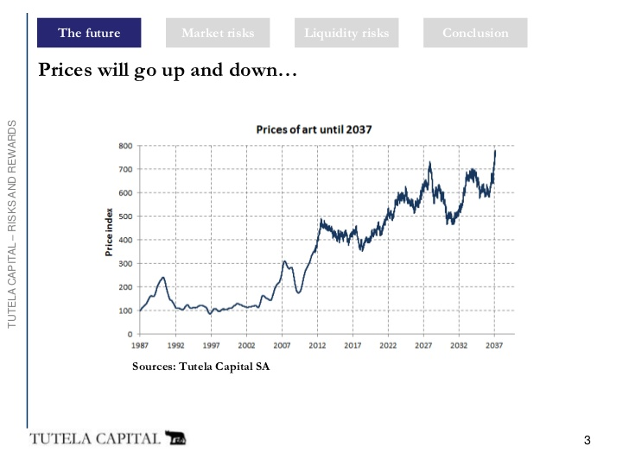
T-20 T-15 T-10 T-5 T0 T5 T10 T15 T20
Years
Based on http://www.slideshare.net/TEFAF/tc-presentation-tefaf (accessed September 2016)

Scenario 2: “Art is a cyclical market, but this is still a great moment to buy art!”

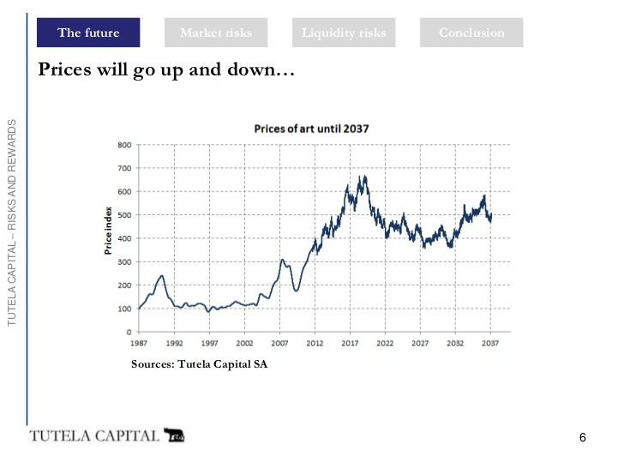
T-20 T-15 T-10 T-5 T0 T5 T10 T15 T20
Years
Based on http://www.slideshare.net/TEFAF/tc-presentation-tefaf (accessed September 2016)

